PRESS RELEASE
FIELD-INSTALLABLE CIRCULAR CONNECTOR M12x1 D-CODED WITH IDC CONTACTS FOR MAXIMUM RELIABILITY EVEN IN MOVING APPLICATIONS.

Steinenbronn, 1st June, 2022. Telegärtner adds a new variant with IDC contacts to its portfolio of M12 circular connectors. The IDC contacts accept solid and stranded wires with 7 and 19 wires per conductor. The connector can be installed on-site quickly and easily without special tools.

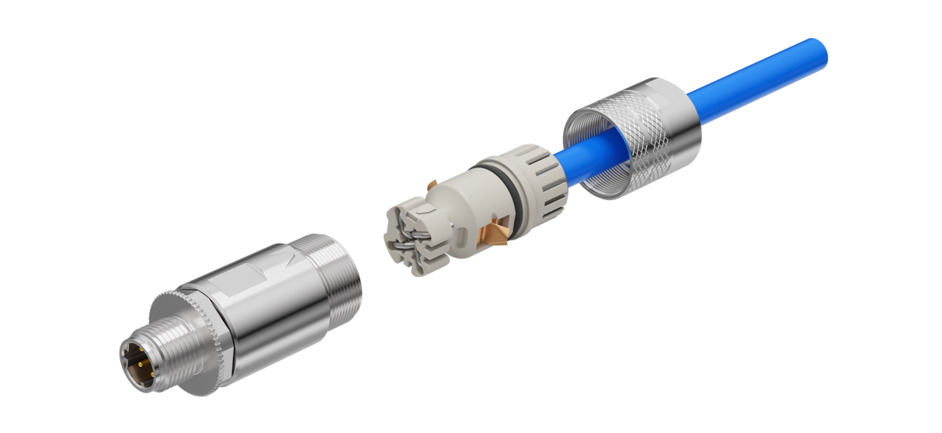

The new M12x1 D-coded IDC is designed for applications with increased requirements regarding reliability and fail-safety even under enormous mechanical stress. Its optimized housing design prevents shorts despite mechanical stress in moving applications. The IDC contacts accept not only solid wires and seven-wire strands but also nineteen-wire strands. The connector accepts wires with an outer diameter of 0.9 to 1.6 mm and cables with an outer diameter of 5.0 to 9.0 mm. The new connector can be installed without special tools quickly and easily on site on a huge variety of different cable types.

“Maximum reliability even under enormous mechanical stress and at the same time fast and particularly easy field-termination without the need for special tools make the M12x1-D IDC the premier choice in fail-safe applications”, says Bianca Ulmschneider, Product Manager DataVoice Copper Solutions at Telegärtner. “Colour coding of both, Profinet and ODVA Ethernet IP is printed on the universal wire manager. Unlike ordinary crimp connectors the M12x1-D IDC also accepts cable with solid wires.”

The M12x1-D IDC is IP67 rated and works in the temperature range of -40 °C to +85 °C. It can transmit Fast Ethernet with data rates of up to 100 Mbps and PoE as specified in IEEE 802.3af.

More information on Telegärtner’s new M12x1-D IDC can be found here.

More about Telegärtner:
Telegärtner was founded in 1945 and is an international full-service provider for professional solutions in telecommunication and data communication technology. Today it is one of the most important manufacturers in its field. The traditional family business is already in the third generation of management. With around 660 employees worldwide, the group generates annual sales up to 100 million euros.

Press contact
Bianca Ulmschneider
Product Manager at Telegärtner
eMail: bianca.ulmschneider@telegaertner.com
Tel.: +49 7157 125-0

